**Task 3: Maximum Independent Set (MIS) combinatorial optimization**

The Maximum Independent Set problem is the problem of finding a subset of vertices within a graph such that firstly, no two vertices within said subset are connected by edges (independent set definition), and secondly, there are no other vertices outside of this subset which can be added to it without violating the independent set criteria (hence maximum). This problem has many business applications [1], ranging from problems with direct application the antenna placement problem to find the best areas to place antennas for network, to related graph problems like the maximum clique problem where it can be used for portfolio optimization for finance, to problems in other fields like propositional satisfiability, which is used very commonly in many logistic problems.

Task 3 asked us to first follow the tutorial to solve the 4 X 4 diagonal-connected unit-disk grid graphs (DUGG) problems using the adiabatic approach as well as using QAOA algorithm. It then asked us how large of an array can Bloqade solve.

We first explored the 4 X 4 DUGG solving it via the adiabatic approach, following the tutorial. Solving it did not take very long, roughly within a minute to be solved. Next, we explored a 4 X 5 DUGG, where it gave the following solution within 30 minutes:

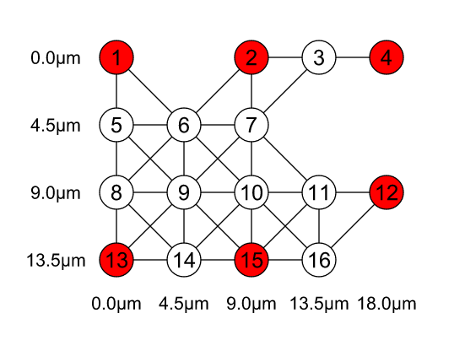

We note that in this case, it used 16 qubits. Lastly, when we tried a 5 X 5 DUGG that looked like the following:

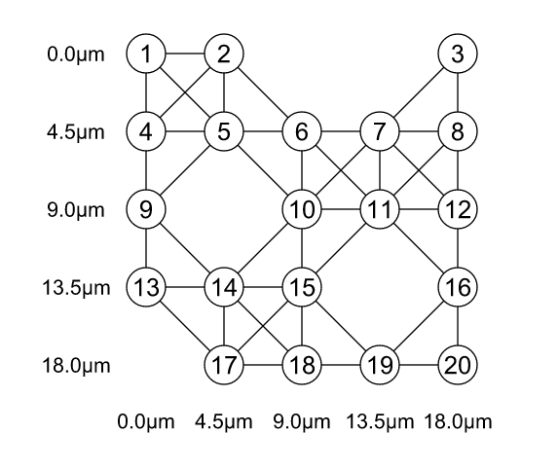

A couple of hours and a crashed computer later, we determined that a 5 X 5 DUGG that used 20 qubits could not be solved. However, it is not so much the size of the lattice that mattered, but instead the number of qubits. The important thing to note while answering this question is that the number of qubits we need to use (and simulate) gets higher proportionally to the number of vertices on the graph, since each qubit literally represents each vertex. Testing again a 5 X 5 DUGG with a higher dropout rate (0.5), we could solve the following graph within a minute too:

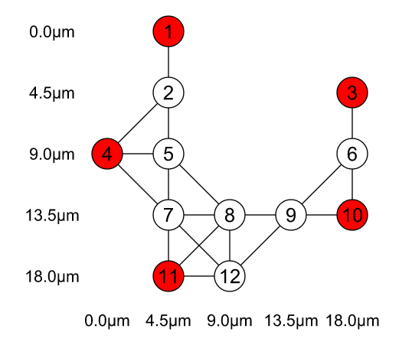

while a 4 X 5 DUGG with no dropout hit that problem too. This is typical of current day quantum computing simulation, where memory usage increases exponentially as qubits increases, hence hitting this problem. We determined that 20 qubits was definitely too large for my computer to solve (although the computer tested on was not very powerful), so the limit should be about there.

However, on the tensor network system that the venture Quantum Galaxies started, we could solve for 60 qubits instead. This is a great increase in the number of qubits we can use, which means we can start solving the MIS problem for much larger systems. See Task 4. Business Application.

[1] Wurtz, Jonathan, et al. "Industry applications of neutral-atom quantum computing solving independent set problems." *arXiv preprint arXiv:2205.08500* (2022).